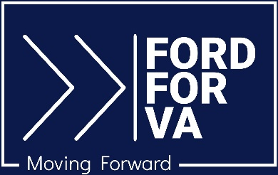

For Immediate Release Media Contact: contact@fordforva.com
7.24.23 540-948-4092 / 571-438-5523 (cell)

Jason Ford Awarded Moms Demand Action Candidate Distinction

Culpeper, VA – Moms Demand Action, a nationwide, grassroots organization focused on gun violence prevention, has awarded Jason Ford the 2023 Moms Demand Action Gun Sense Candidate Distinction. Ford is a candidate for the Virginia State Senate in the 28th District.

The distinction is presented to candidates who advocate for gun violence prevention and are committed to governing with gun safety in mind.

Ford, who has resided in Culpeper for the past 20 years, is a gun owner who supports policies that reduce gun violence, protect children, and make communities safer. “Common-sense gun safety measures help keep guns out of the hands of criminals and those in crisis,” says Ford. “Background checks and red flag laws are among the proven tools that law enforcement agencies rely on to keep our communities safe. With gun violence the number one cause of child mortality in the country, we need to continue to take critical steps to encourage gun safety and responsible gun ownership.”

More information can be found at Ford’s campaign website, FordforVA.com; on Facebook at Jason Ford for VA SD-28; and on Instagram at @ajasonford.

# # #

