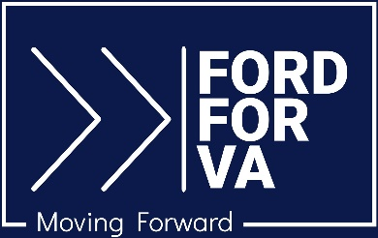

For Immediate Release Media Contact: contact@fordforva.com
7.12.23 540-948-4092 / 571-438-5523 (cell)

Jason Ford Endorsed by Clipboard PAC

Culpeper, VA – Jason Ford, Democratic candidate in the new 28th Senate District in Virginia, has been endorsed by Clipboard PAC, a nationwide grassroots political action committee dedicated to electing the next generation of young progressives.

“If elected, Jason will be the youngest member of the Virginia Senate in almost 200 years. His campaign is focused on protecting reproductive freedom, preserving clean air and water, and reducing the cost of childcare,” the PAC stated on its website at ClipbordPAC.org.

The 28th District covers all of Culpeper, Greene, Orange, Madison, and Rappahannock counties and parts of Fauquier and Spotsylvania counties.

Ford is 24 years old and has resided in Culpeper for the past 20 years. He is a manager with the Rappahannock Goodwill Career Centers in Culpeper and Orange Counties. He holds a Political Science degree from the University of Mary Washington (2020) and is a graduate of Culpeper County High School.

In his current role with Rappahannock Goodwill, Ford assists the regional community with workforce development initiatives, assisting youth and adults in accessing training, education, and employment opportunities. He has worked extensively with regional businesses and agencies to prioritize education and skills development, with a focus on creating a well-trained local workforce. Ford also serves as a volunteer mentor and coach with the Entrepreneurial Energy (E²) program as part of the Virginia Career Partners program, working with Culpeper high school students on team building and project-based learning.

“I have decided to run this year to give people the choice to vote for a candidate who represents their values—people who care about maintaining access to safe reproductive healthcare, support the public education system, and believe in investing in affordable housing options,” Ford says.

More information can be found at Ford’s campaign website, FordforVA.com; on Facebook at Jason Ford for VA SD-28; and on Instagram at @ajasonford.

# # #

