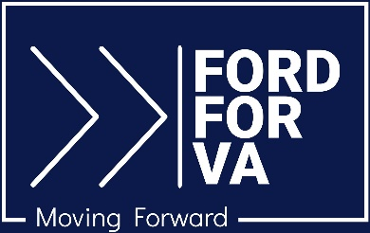

For Immediate Release Media Contact: contact@fordforva.com
7.28.23 540-948-4092 / 571-438-5523 (cell)

WinVirginia Endorses Jason Ford

Culpeper, VA – WinVirginia, a business- and technology-based organization focused on upholding democratic principles and values, has endorsed Jason Ford for the Virginia State Senate in the 28th District.

Composed of leaders from diverse fields such as business, technology, entertainment, and real estate, WinVirginia is committed to restoring Virginia’s tradition of democratic principles and the Jeffersonian values of truth, compassion, and dignity. The organization espouses truth and transparency in government, protection of the most vulnerable in society, and the ability for all to live their lives with dignity, including affordable access to healthcare.

“A commitment to our nation’s founding ideals is central to my beliefs and what I hope to bring to our state government,” says Ford. “It’s time to eradicate closed-door politics and deal-making that disregards the needs of so many in our communities. I hope to give voice to all in the 28th District, including those who have long been underrepresented.”

More information can be found at Ford’s campaign website, FordforVA.com; on Facebook at Jason Ford for VA SD-28; and on Instagram at @ajasonford.

# # #

