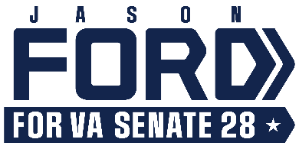

For Immediate Release Media Contact: contact@fordforva.com
8.31.23 540-948-4092 / 571-438-5523 (cell)

Virginia AFL-CIO Endorses Jason Ford

Candidate Recognized for Supporting Workers

Culpeper, VA – The Virginia AFL-CIO has announced its endorsement of Jason Ford, candidate for the State Senate in District 28.

“I am proud to announce that at our Virginia AFL-CIO Convention the delegates voted to endorse Jason Ford,” Doris Crouse-Mays, president of the organization, stated in a recent announcement.

The Virginia AFL-CIO monitors and supports legislation that will affect working Virginians. Recent advocacy work has addressed worker’s compensation laws, workplace safety, unemployment benefits, civil rights and equal rights, and legislation requiring local governments to offer healthcare to retirees. The organization’s mission includes keeping the state’s labor standards on a progressive track that will support all working people; and taking action at the local, county, and state level.

Ford’s career has focused on workforce development and helping local youth and adults find access to training, education, and employment. He has pledged his commitment to a higher minimum wage and family-friendly workplace policies and protections.

Among upcoming events, Jason Ford will attend Taste of the Mountains in Madison this coming Saturday, September 2. The Ford Campaign will also host a rally in Culpeper’s Yowell Meadow Park on Sunday, September 17 from 1 to 4 pm.

The 28th District includes all of Culpeper, Greene, Madison, Orange, and Rappahannock counties, and parts of Fauquier and Spotsylvania counties. More information can be found at Ford’s campaign website, FordforVA.com; on Facebook at Jason Ford for VA SD-28; and on Instagram at @FordforVA.

# # #

