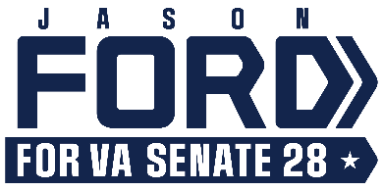

For Immediate Release Media Contact: contact@fordforva.com
8.2.23 540-948-4092 / 571-438-5523 (cell)

Ford Receives Planned Parenthood Advocates of Virginia Endorsement

Candidate Commits to Protecting Reproductive Rights in the Commonwealth

Richmond, VA – Planned Parenthood Advocates of Virginia has announced its endorsement of Jason Ford, candidate for the State Senate in District 28.

“The majority of Virginians support access to reproductive healthcare, including abortion,” says Ford. “I am proud to receive the endorsement of Planned Parenthood Advocates of Virginia, and I am committed to protecting access to abortion care here in the commonwealth. I support the rights of all Virginians to make their own healthcare decisions along with their doctors and without government intervention.”

“A year after the overturning of Roe v. Wade, reproductive rights remain under attack and access to safe, legal abortion has been decimated across the South,” says Jamie Lockhart, executive director of Planned Parenthood Advocates of Virginia. “There is no doubt that Virginians require bold leadership to defend and expand our access to essential healthcare, including abortion. The unacceptable alternative is that Virginia becomes the last state in the South to ban abortion.

Planned Parenthood Advocates of Virginia is proud to endorse Jason Ford because we know he stands with the majority of Virginians who support access to safe, legal abortion. With a pro-reproductive rights majority in the General Assembly, we know that essential healthcare and reproductive rights will be protected and Governor Glenn Youngkin’s abortion ban will be defeated. With majorities in both the House and Senate, we will have the opportunity to not just protect our rights now, but to pass a constitutional amendment to protect our rights for years to come. Make no mistake - everything is on the line.”

According to a recent Washington Post-Schar School poll, 75% of Virginians want abortion laws to be less strict or remain the same. In January, a Wason Center at Christopher Newport University poll found that 72% of Virginians want abortion laws to stay the same or be less restrictive.

The 28th District includes all of Culpeper, Greene, Madison, Orange, and Rappahannock counties, and parts of Fauquier and Spotsylvania counties. More information can be found at Ford’s campaign website, FordforVA.com; on Facebook at Jason Ford for VA SD-28; and on Instagram at @ajasonford.

# # #

